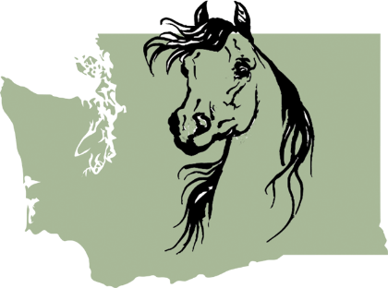

Half Arabian Club of Washington
60th Annual Mid-Summer Classic Dual Horse Shows
Benefiting the American Cancer Society
June 10-13, 2021 ϕ Monroe, Washington
Help us celebrate this exciting milestone of 60 years!
SHOW MARKETING OPPORTUNITIES
CLASS SPONSORSHIPS
Regular classes, leadline, walk trot $25
Championship classes or Business Card $50

GOLD SPONSOR $150
Includes 7 Class sponsorships

SPONSOR OF HONOR $300
Includes 10 Class sponsorships, advertising banner (supplied by the show), half page B&W advertisement in official horse show program

RUBY (Premier) SPONSOR $400
Includes: 14 Class sponsorships, full page B&W advertisement in the official horse show program, advertising banner placed in a high traffic area, facebook & website links to your business, reserved parking. Sponsorship received by March 1, 2021 will also receive the added bonus of recognition in the online Official Prize list.

EMERALD (Sapphire) SPONSOR $600
Includes: 18 Class sponsorships, full page B&W advertisement in the official horse show program, multiple advertising banners placed in high traffic area, facebook & website links to your business, reserved parking. Sponsorship received by March 1, 2021 will also receive the added bonus of recognition in the online Official Prize list.

SHOW PROGRAM ADVERTISING .... call or email for quote
— P L E A S E P R I N T —
COMPANY _____________________________________________________________________________________________
CONTACT NAME _______________________________________________________________________________________
ADDRESS ______________________________________________________________________________________________
CITY, STATE, ZIP _______________________________________________________________________________________
PHONE __________________________ __________EMAIL ____________________________________________________
WEBSITE ______________________________________________________________________________________________
INFORMATION TO APPEAR ON BANNER _________________________________________________________________
LEVEL OF SPONSORSHIP (_) Class (_)Championshio class (_) Gold (_) Honor (_) Ruby (_) Emerald
REQUESTED CLASS NOS. # # # # # # #
Contact Chairperson: Jennifer Rader
425-501-2762 email: Jennifer@jenniferrader.com
All sponsorships received by May 19th will be acknowledged in the show program, and receive recognition and thanks from the show announcer during the class. Sponsors may submit their web link for placement on the HACW website.
Make checks payable to HACW
Mail to: Bonny Braden, 11913 Seattle Hill Road, Snohomish WA 98296
DEADLINE FOR SPONSORSHIPS: MAY 19, 2021
Camera Ready Ad Copy to be sent to: Jennifer Rader at jennifer@jenniferrader.com
HACW is a non-profit corporation.

